Project 8: Numerical Integration

Austin Johns and Shelby Clow

Grand Canyon University

CST-305: Principles of Modeling and Simulation

**Required Software and Libraries**

For all parts of this project, the same libraries are imported. 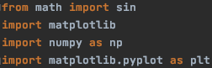

Sin from math is used to calculate sin when graphing Riemann integral.

Matplotlib is used to plot the data.

Numpy is used to evaluate the equations

Pyplot is used to plot in python.

**Program Execution**

All files in the program execute without a problem. Execution for each file can be seen below in the screenshots:

Part 1a

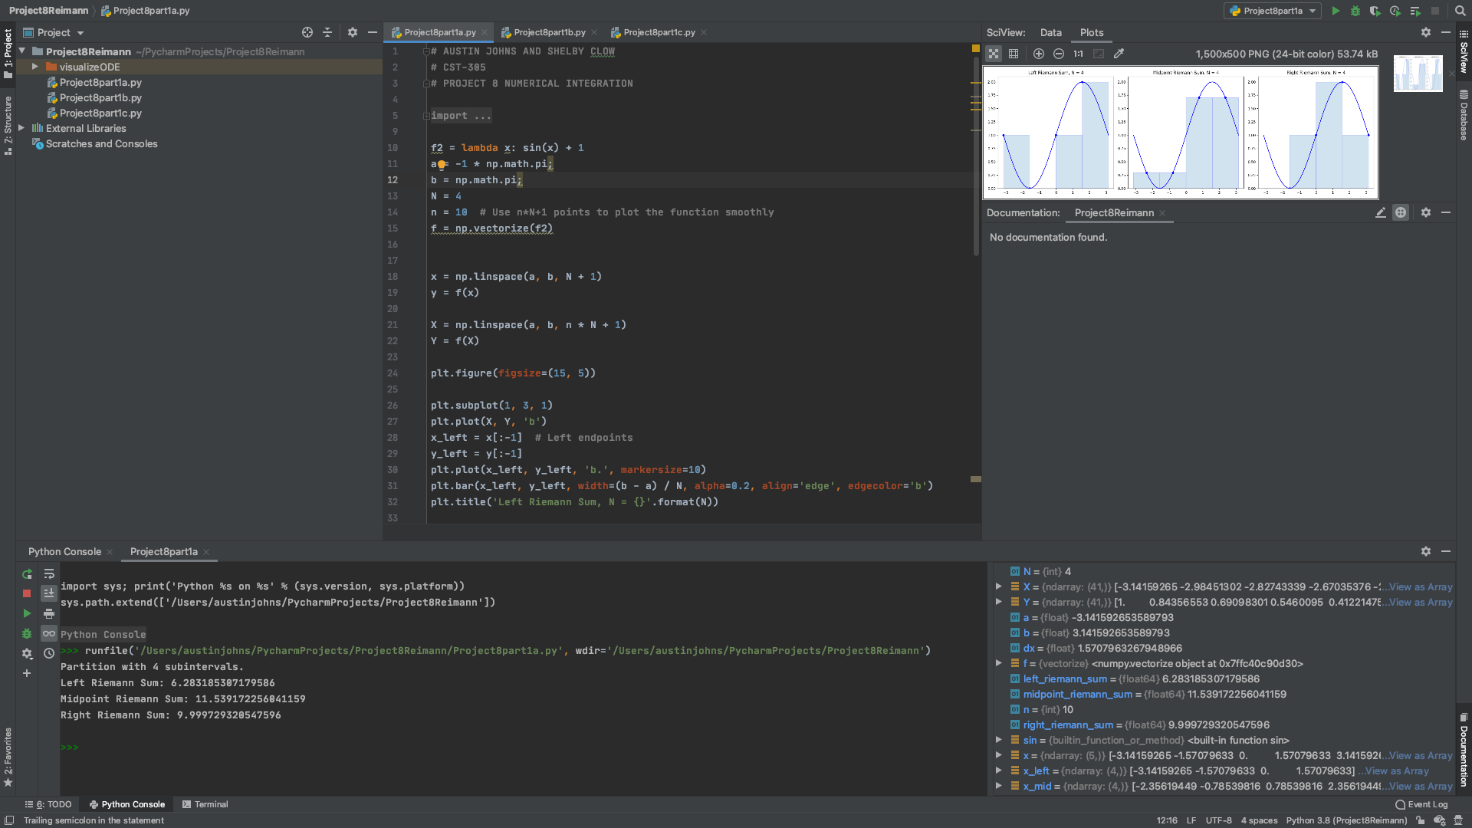

Part 1b

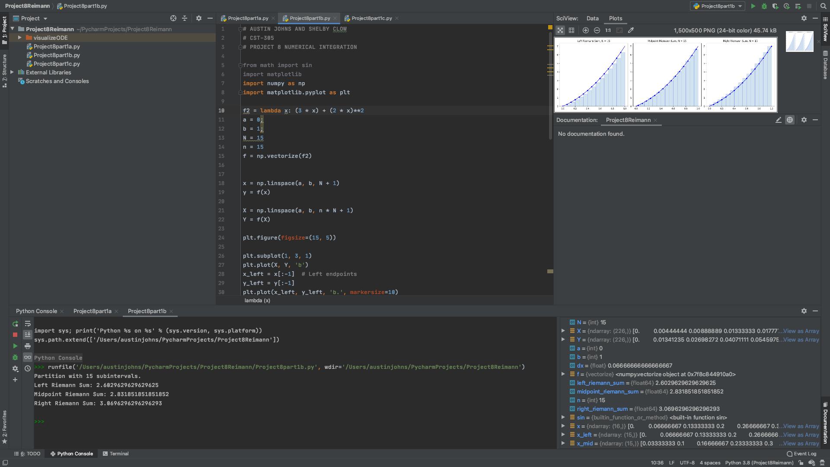

Part 1c

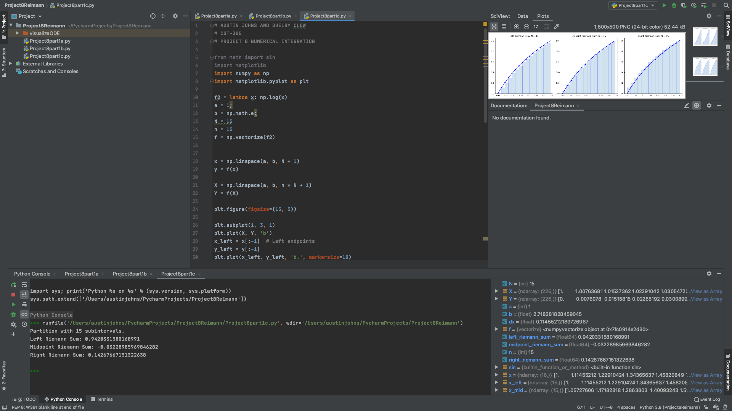

Part 2

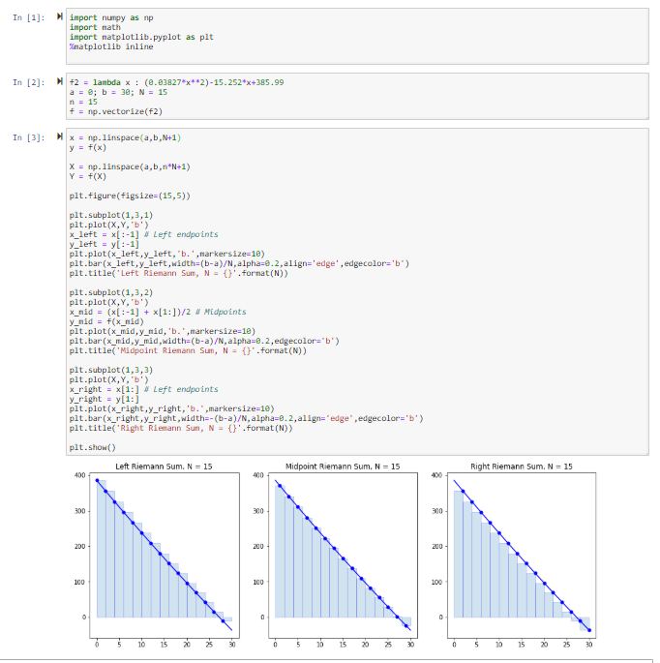

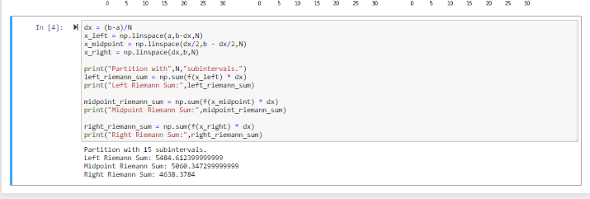

**Mathematical Methods in Code**

The mathematical methods in the code follow the calculations of the Riemann Integral. To begin, the equation that is being integrated is claimed as f2. After this, the a and b of the integral are declared in the code to give the correct interval for calculation. Then, the array of data is vectorized to be used in plotting with python.

Now, the subplots for the left, mid, and right points of Riemann integral can be shown in one image. The subplots set the data points based on the placement of the integral. This creates slightly different data points, depending on how many data points are specified for the equation. If not specified, the number of data points per plot in this project is $n = 15$. Next, all plots are combined into one image and the left, middle, and right Riemann sum are printed in the console.

**Program Output**

The output of the program includes calculations for the left, middle, and right Riemann sum along with the corresponding plots.

Part 1a

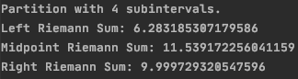



Part 1b

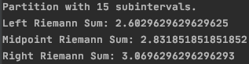

Part 1c

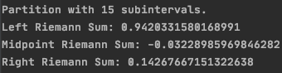

**Programming Style**

The programming style for this project has been kept fairly straightforward. The code style is structured and kept as simple as possible without sacrificing complexity when needed. In the code for each part, all libraries are defined, then the equation is quickly identified for the manipulation of the python code. Each graphing step is kept separate from the other in order to increase readability without sacrificing functionality.

**Mathematical Methods**

Definite integrals are used as a representation of the area under the curve of a function. This area can be approximated by using the Riemann sum method. This method of approximation separates this area into a certain amount of subdivisions. Using large amounts of these subdivisions brings a more accurate approximation, with the largest amount being infinity. In order to find this estimation with infinity amount of subdivisions, the limit of the integral needs to be taken. This limit will give the best approximation of the area under the curve of a function.

**Execution Screenshots**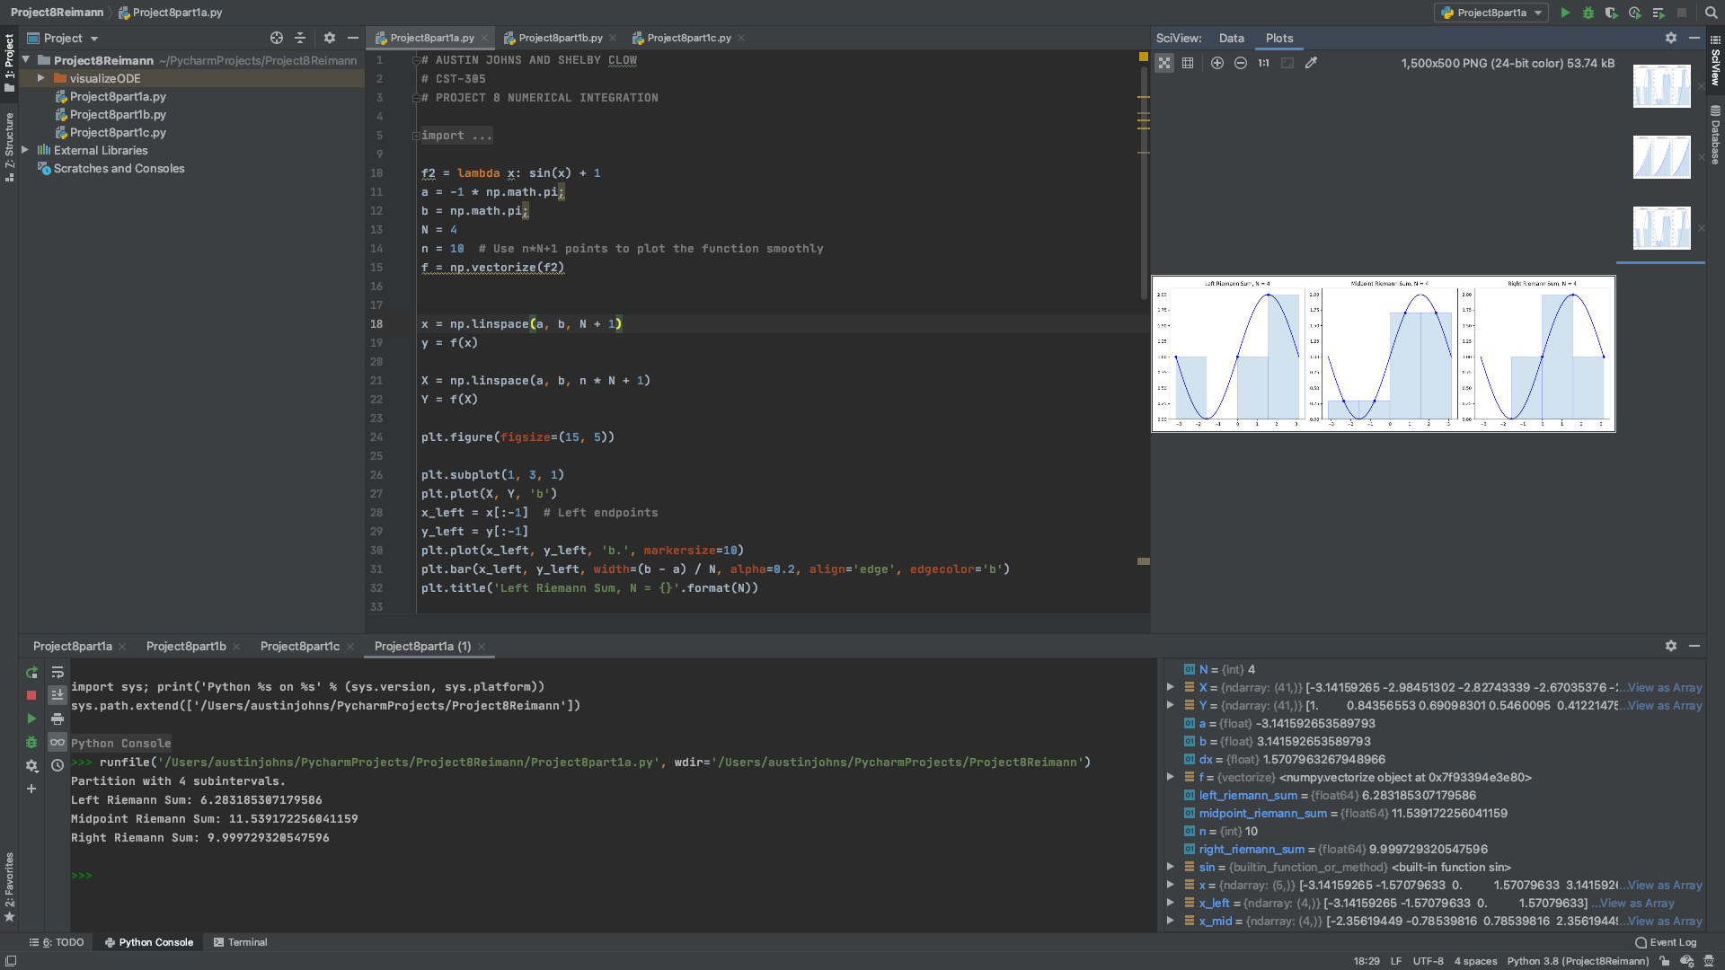

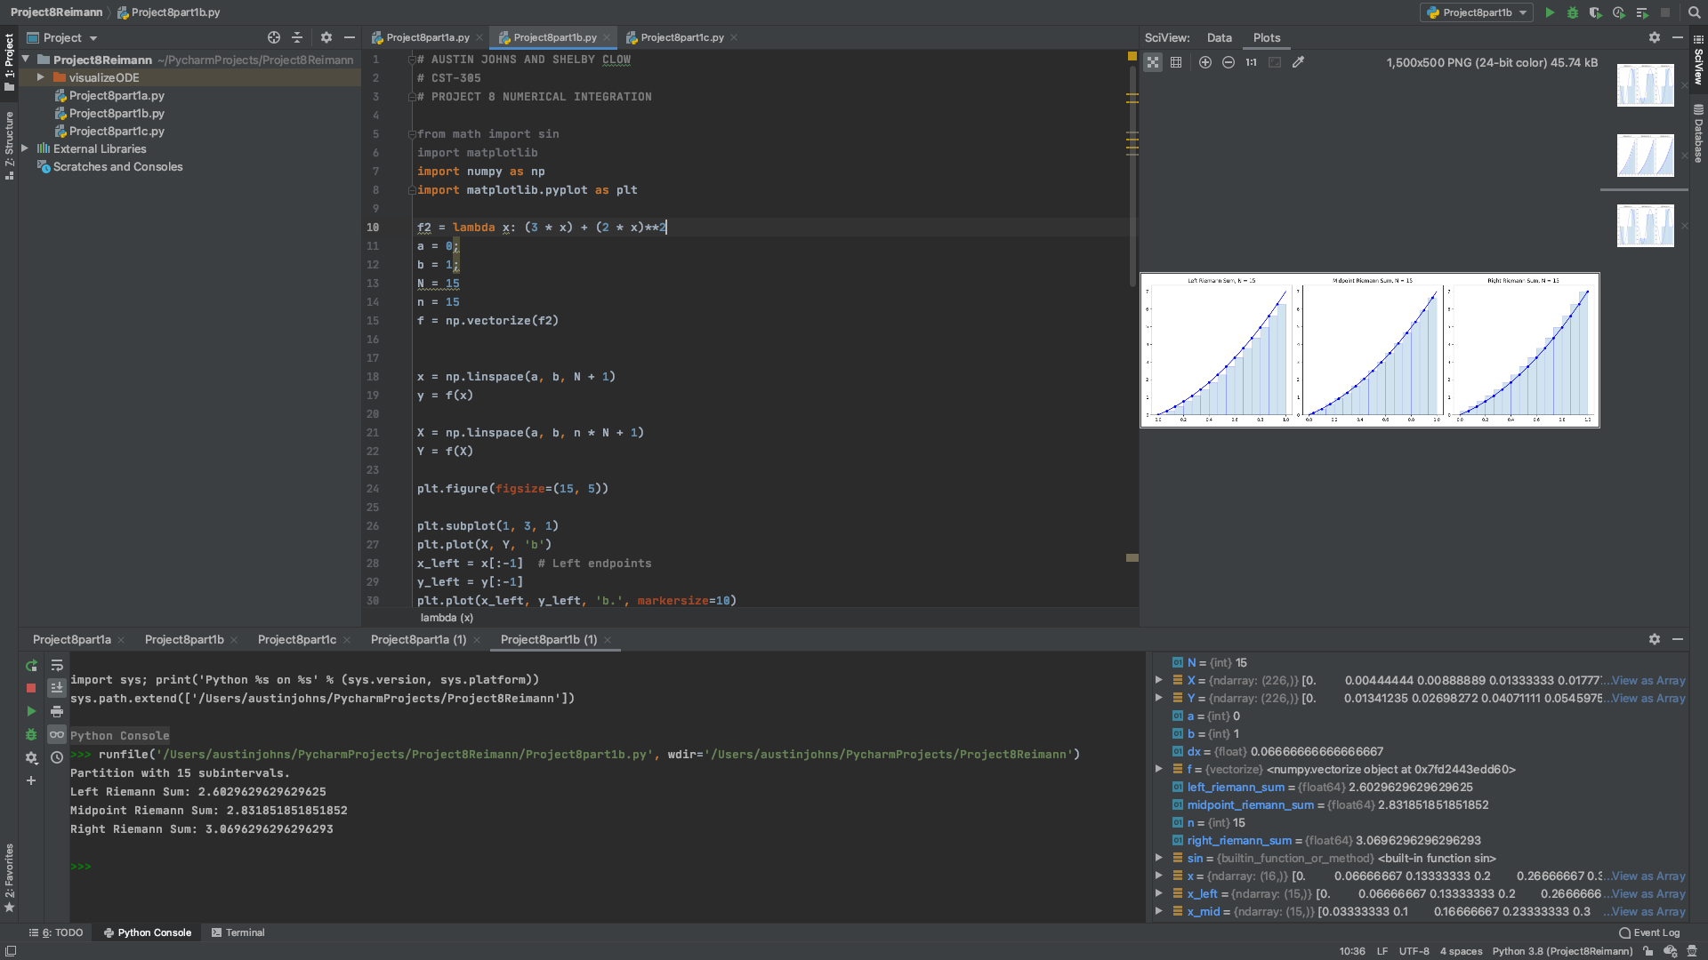

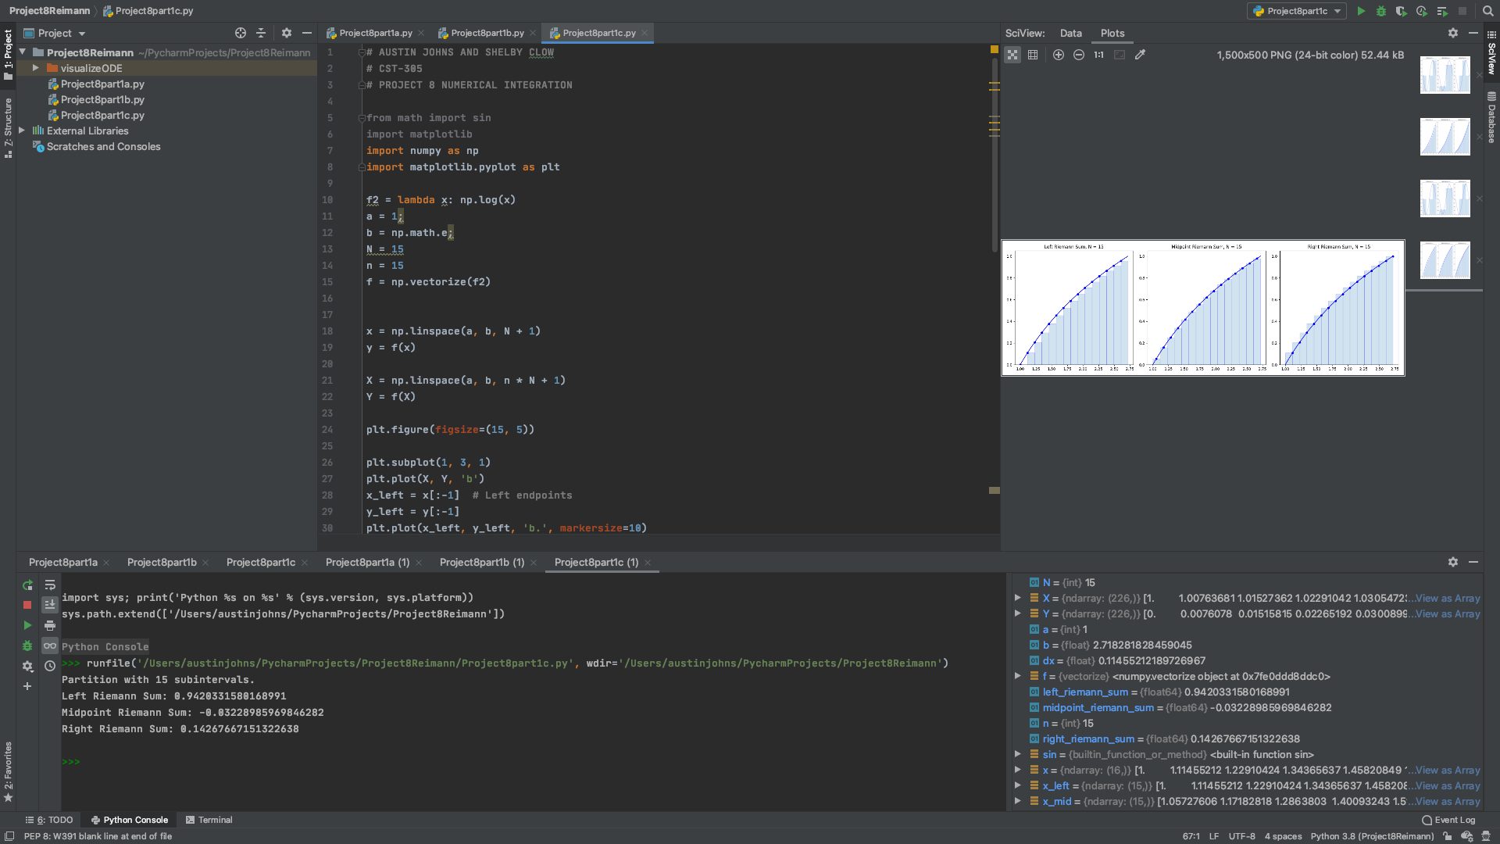

**README**

Screenshot of the README for Project 8

